

Always give an indicators while changing the lanes

Do not use mobile phones while driving

obey the traffic rules and regulations

Use public vehicles for better transportation

Empathy Map Canvas

Gain insight and understanding on solving customer problems.

|  |  |
| --- | --- |
| **Date** | **01-10-2022** |
| **Team ID** | **PNT2022TMID37463** |
| **Project Name** | **Signs with Smart Connectivity for Better Road Safety** |

1

Build empathy and keep your focus on the user by putting yourself in their shoes.

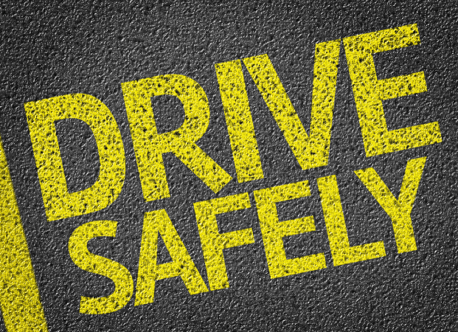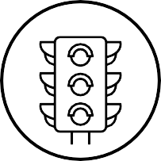

Avoid drink and driving

Be focus on traffic Signals

Wear helmets and seatbelts while driving

Most dangerous one

Protect from accident

Enforced speed limits

how can I avoid accidents

safest drive and use headlights properly

Service your vehicles regularly

Cities without accidents

avoid night riding

Peaceful Environment

Injures to health

some unpredictable pain

getting Irritating of noise

No violation charges

Reduce accidents

Maximum protection